**EXPERIMENT 9**

**Aim : (a)** Learn how to raise and report Bugs using Bug Tracking Tool **- Bugzilla**

**Introduction**

Bugzilla is an open-source issue/bug tracking system that allows developers to keep track of outstanding problems with their products. It is written in Perl and uses the MYSQL database.

Bugzilla is a Defect tracking tool; however, it can be used as a test management tool as such it can be easily linked with other Test Case management tools like Quality Centre, Test link, etc.

This open bug-tracker enables users to stay connected with their clients or employees, to communicate about problems effectively throughout the data - management chain.

**Key Features**

* Bugzilla is powerful and it has advanced searching capabilities.
* Bugzilla supports user-configurable email notifications whenever the bug status changes.
* Bugzilla displays the complete bug change history.
* Bugzilla provides an inter bug dependency track and graphic representation.
* Bugzilla allows users to attach Bug supportive files and manage them.
* Bugzilla has an integrated, product-based, granular security schema that makes it more secure.
* It has a complete security audit and runs under Perl’s taint mode.
* Bugzilla supports a robust, stable RDBMS (Rational Data Base Management System) back end.
* It supports Web, XML, E-Mail, and console interfaces.
* Bugzilla has a wide range of customized, user preferences features.
* It supports a localized web user interface.
* Bugzilla has a smooth upgrade pathway among different versions.

**Steps for Creating a Bug Report in Bugzilla**

***Step 1:*** To create a new bug in Bugzilla, visit the home-page of Bugzilla and click on the NEW tab from the main.

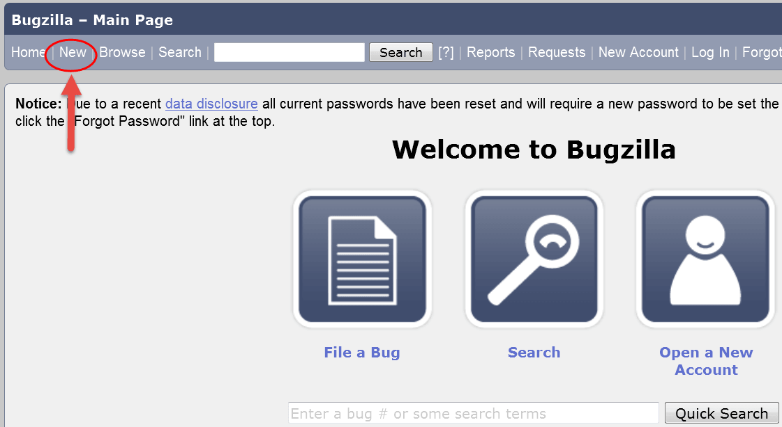

***Step 2:*** In the next window

1. Enter Product -> Enter Component-> Give Component description-> Select version->Select severity ->Select Hardware-> Select OS-> Enter Summary-> Enter Description-> Attach Attachment
2. Submit

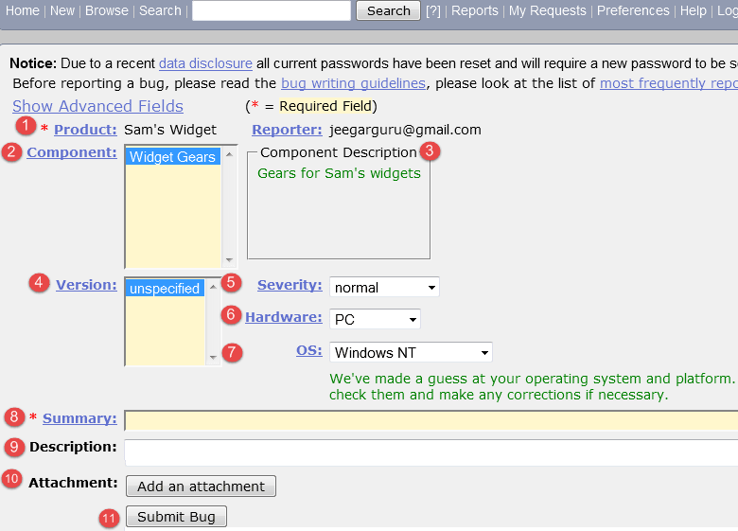

***Step 3:*** The bug is created ID# 26320 is assigned to our Bug. You can also add additional information to the assigned bug-like URL, keywords, whiteboard, tags, etc. This extra information is helpful to give more detail about the Bug you have created.

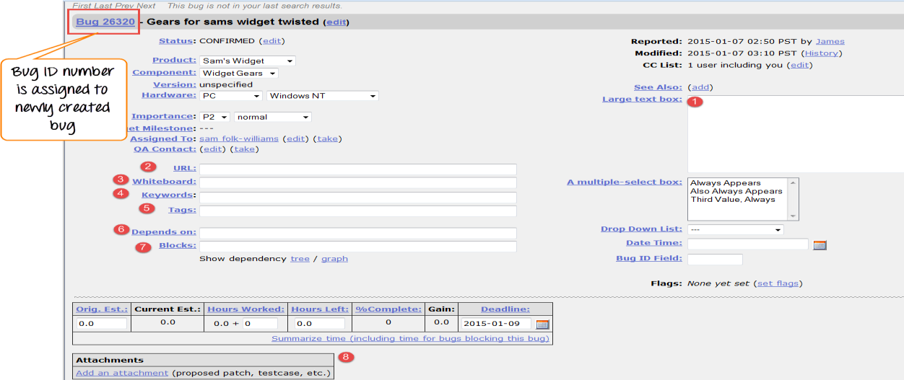

***Step 4:*** In the same window if you scroll down further. You can select the deadline date and also the status of the bug. The deadline in Bugzilla usually gives the time-limit to resolve the bug in a given time frame.

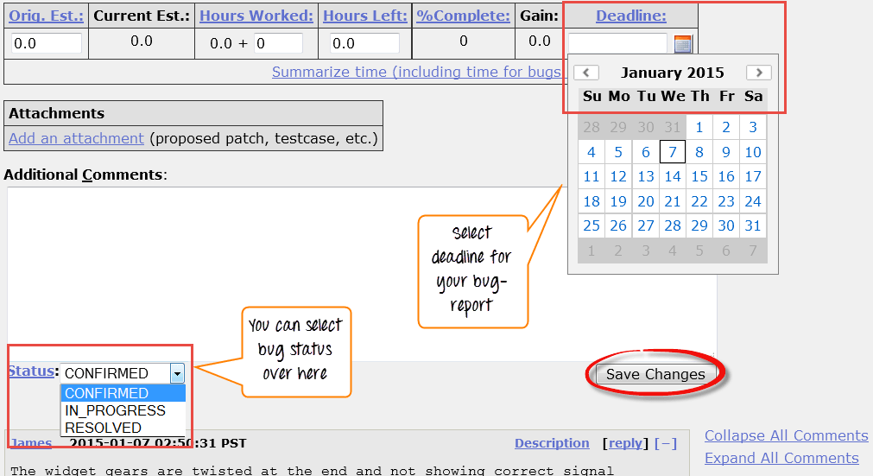

**Aim : (b)** To study Open Source Testing Tool **- SELENIUM**

**Introduction**

Selenium is one of the most widely used open- source Web UI automation testing suite. It was originally developed by Jason Huggins in 2004 as an internal tool at Thought Works. Selenium supports automation across different browsers, platforms, and programming languages. Selenium can be easily deployed on platforms such as Windows, Linux, Solaris, and Macintosh. Moreover, it supports OS (Operating System) for mobile applications like iOS, windows mobile, and android.

Selenium supports a variety of programming languages through the use of drivers specific to each language. Languages supported by Selenium include C#, Java, Perl, PHP, Python, and Ruby. Currently, Selenium Web driver is most popular with Java and C#. Selenium test scripts can be coded in any of the supported programming languages and can be run directly in most modern web browsers. Browsers supported by Selenium include Internet Explorer, Mozilla Firefox, Google Chrome, and Safari.

**Features**

* Selenium is an open-source and portable Web testing Framework.
* Selenium IDE provides a playback and record feature for authoring tests without the need to learn a test scripting language.
* It can be considered as the leading cloud-based testing platform which helps testers to record their actions and export them as a reusable script with a simple-to-understand and easy-to-use interface.
* It also supports parallel test execution which reduces time and increases the efficiency of tests.
* Selenium can be integrated with frameworks like Ant and Maven for source code compilation.
* Selenium can also be integrated with testing frameworks like TestNG for application testing and generating reports.
* Selenium requires fewer resources as compared to other automation test tools.
* WebDriver API has been indulged in selenium which is one of the most important modifications done to selenium.

**Selenium Tool Suite**

Selenium is not just a single tool but a suite of software, each with a different approach to supporting automation testing. It comprises four major components which include:

**1. Selenium Integrated Development Environment (IDE)**

Selenium IDE is implemented as a Firefox extension which provides record and playback functionality on test scripts. It allows testers to export recorded scripts in many languages like HTML, Java, Ruby, RSpec, Python, C#, JUnit, and TestNG. You can use this exported script in Selenium RC or Webdriver. Selenium IDE has limited scope and the generated test scripts are not very robust and portable.

**2. Selenium Remote Control**

Selenium RC (officially deprecated by selenium) allows testers to write automated web application UI tests in any of the supported programming languages. It also involves an HTTP proxy server which enables the browser to believe that the web application being tested comes from the domain provided by the proxy server. Selenium RC comes with two components:

* Selenium RC Server (acts as an HTTP proxy for web requests).
* Selenium RC Client (library containing your programming language code).

**3. Selenium WebDriver**

Selenium WebDriver (Selenium 2) is the successor to Selenium RC and is by far the most important component of Selenium Suite. Selenium WebDriver provides a programming interface to create and execute test cases. Test scripts are written to identify web elements on web pages and then desired actions are performed on those elements.

Selenium WebDriver performs much faster as compared to Selenium RC because it makes direct calls to the web browsers. RC on the other hand needs an RC server to interact with the web browser. Since WebDriver directly calls the methods of different browsers, hence we have separate drivers for each browser. Some of the most widely used web drivers include:

* Mozilla Firefox Driver (Gecko Driver)
* Google Chrome Driver
* Internet Explorer Driver
* Opera Driver
* Safari Driver
* HTML Unit Driver (a special headless driver)

**4. Selenium Grid**

Selenium Grid is also an important component of Selenium Suite which allows us to run our tests on different machines against different browsers in parallel. In simple words, we can run our tests simultaneously on different machines running different browsers and operating systems.

Selenium Grid follows the Hub-Node Architecture to achieve parallel execution of test scripts. The Hub is considered as the master of the network and the other will be the nodes. Hub controls the execution of test scripts on various nodes of the network.

**Limitations**

* Selenium does not support automation testing for desktop applications.
* Selenium requires high skill sets to automate tests more effectively.
* Since Selenium is open-source software, you have to rely on community forums to get your technical issues resolved.
* We can't perform automation tests on web services like SOAP or REST using Selenium.
* We should know at least one of the supported programming languages to create test scripts in Selenium WebDriver.